1. **Discuss three different construction methods of the spatial weight matrix W. Describe potential benefits from using each and every of them - under what circumstances can they adequately characterize the network of connections between the observed units?**

Types:

* Distance-based matrix
* Neighborhood-based matrix
* Economic distance
* K-nearest neighbors
* In a given radius-> point data

1. **Why is a balanced panel much more important in spatial panel econometrics than in non-spatial panels? What are the consequences of using unbalanced panels for estimating the non-spatial parameters (β) and spatial ones (*ρ, λ, θ*)? How does the choice of W matrix matter in this case?**

Unbalanced panel influences the whole region, so instead of losing 1 observation, we miss 5 in the same period as they are neighbors

in this case rho is biased downwards and we receive incorrect estimations.

1. **Discuss how to interpret the non-spatial coefficients (β) in the models of type SAR / SLM. Present the three measures that we normally use for this purpose. Why is it inappropriate to use the standard interpretation template from linear models (i.e. if *x*1 grows by a unit; then *y* ceteris paribus grows by β1 on average...)?**

Speak about effects:

* Direct
* Indirect
* Total

Standard template interprets the parameter as a derivative.

In SAR model β is not a derivative

1. **Write the spatial Durbin model; introducing the notation; and derive the matrix of spatial multipliers for a selected variable in this model. What is the interpretation of the element (1;2) of this matrix?**

SDM formula with interpretations:

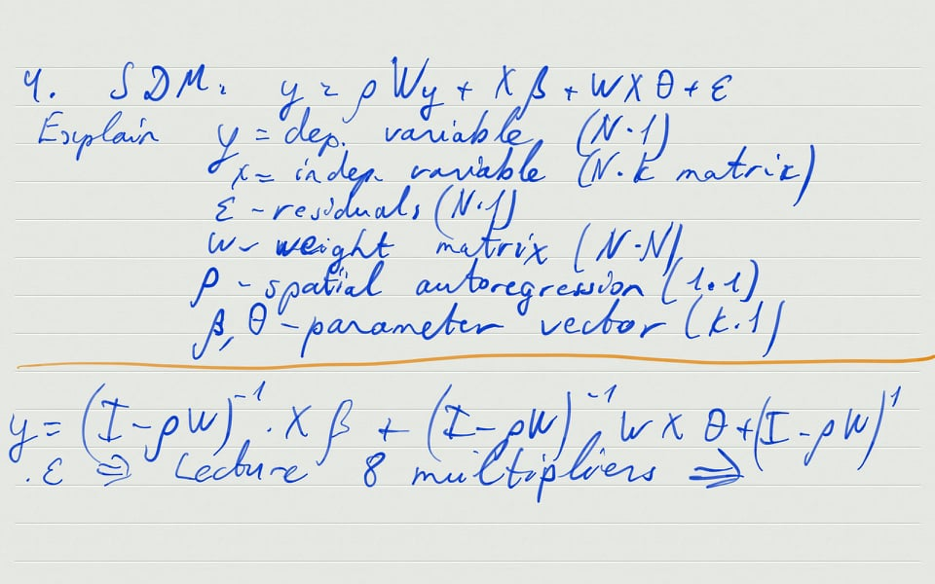

Take derivative dy/dx and interpret (Lecture 8 multipliers – page 13)

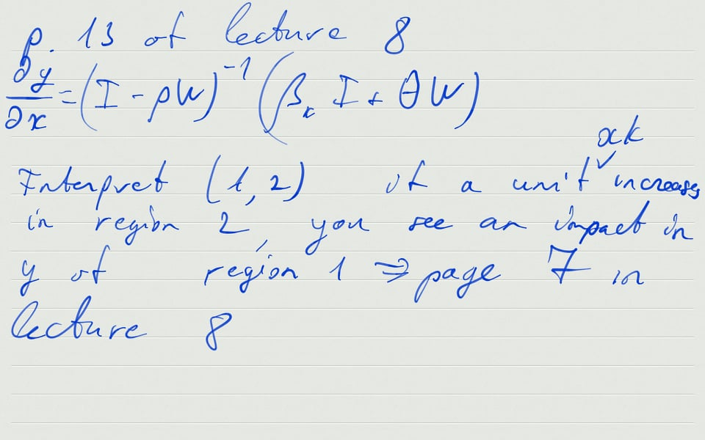

**What is the interpretation of the element (1;2) of this matrix?**

If a unit xk increases in region 2, we see an impact in y of region 1 (page 7 in lecture 8)

1. Which property of the 0LS estimator does not hold; if one uses it for the estimation of the following model?

**y** = **Xβ**+ (**I** *− λ***W**)-1 ***ε***

* 1. unbiasedness
  2. consistency
  3. efficiency
  4. unbiasedness; consistency and efficiency

*if we have (I − λW)-1 *y= Xβ+ ε then answers a and b*

1. Which construction method of matrix ***W*** ensures that there will be no isolated regions; i.e. regions unconnected to any other region?
   1. contingency neighbourhood matrix
   2. inverse distance matrix
   3. neighbourhood matrix within a given radius
   4. matrix of adhesion to the higher-order administrative unit

*answer a for border neighbours, answer c for radius*

1. According to a hypothesis formulated by the marketing department of a press; consumers are more keen to purchase calendars with photos of dogs; if their Facebook friends do so. Besides; this decision is also determined by their wealth; the fact of having a dog; and gender. What model could serve as a framework for verifying this hypothesis?
   1. non-spatial linear
   2. SAR / SLM
   3. SEM
   4. SLX
2. Which test is appropriate to verify the hypothesis of spatial process for a binary variable?
   1. Moran's
   2. modified Moran's
   3. Geary's
   4. joincount
3. Three non-spatial linear models have been tested for the presence of spatial process. The results are presented below. Which specification is preferred?

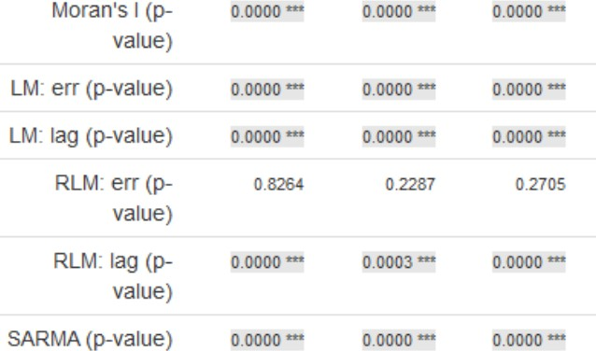

* 1. non-spatial linear
  2. SEM
  3. SAR / SLM
  4. two-source

From test interpretation